**Transaksi Pemesanan Barang pada Aplikasi Penjualan**

* **Tampilan Form Penjualan**

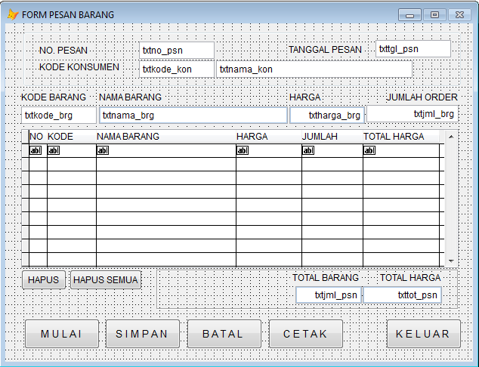

cmdMulai cmdSimpan cmdBatal cmdCetak cmdKeluar

cmdHapus cmdHapus_semua Grid1

**Properti Grid1**

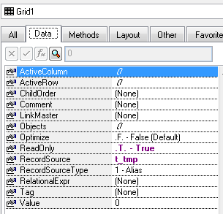

**Tab Order object**

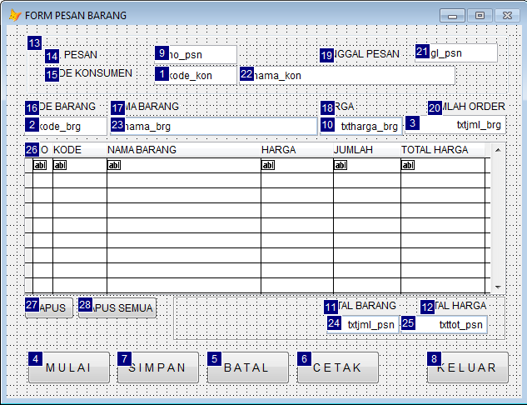

* Data Environment

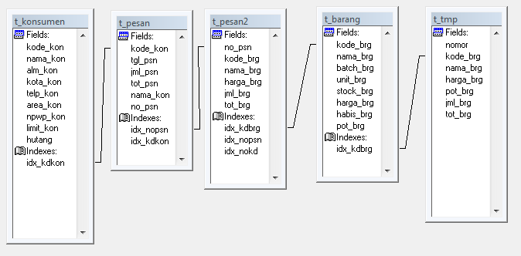

* **Struktur Tabel**
  + **Tabel T_Barang**

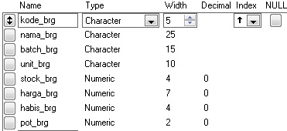



* + **Tabel T_Konsumen**

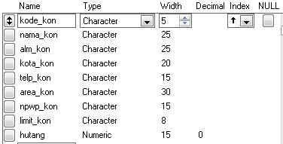



* + **Tabel T_Pesan**

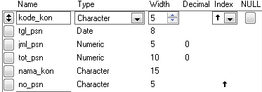



* + **Tabel T_Pesan2**

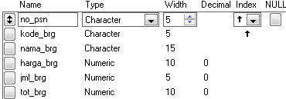

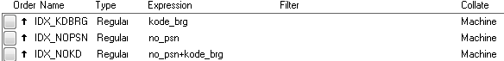

* + **Tabel T_TMP**

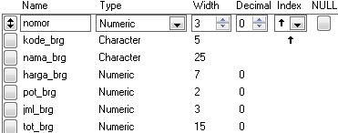



* + **Tabel T_TMP1**

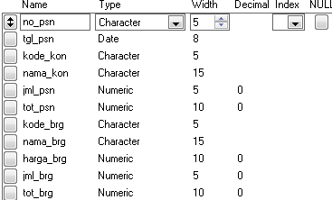

* + **Tabel T_Nopesan**





* **Property/Method pada Form Pemesanan**

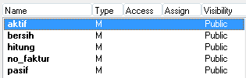

* **Listing Kode Program**

|  |  |  |  |
| --- | --- | --- | --- |
| **Object:** | **F_pesan** | **Procedure:** | **Activate** |

thisform.pasif()

|  |  |  |  |
| --- | --- | --- | --- |
| **Object:** | **F_pesan** | **Procedure:** | **Load** |

CLOSE INDEX

CLOSE ALL DATABASE

SET DELE ON

set safe off

SELECT 1

USE

USE T_KONSUMEN

SET ORDER TO TAG IDX_KDKON

SELECT 2

USE

USE T_BARANG

SET ORDER TO TAG IDX_KDBRG

SELECT 4

USE

USE T_TMP EXCLUSIVE

ZAP

SET ORDER TO TAG IDX_NOMOR

SELECT 5

USE

USE T_PESAN

SET ORDER TO TAG IDX_NOPSN

SELECT 6

USE

USE T_PESAN2

SET ORDER TO TAG IDX_NOKD

SELECT 7

USE

USE T_NOPESAN

SET ORDER TO TAG IDX_NOPSN

SELECT 8

USE

USE T_TMP1 EXCLUSIVE

ZAP

SELECT 1

|  |  |  |  |
| --- | --- | --- | --- |
| **Object:** | **F_pesan** | **Procedure:** | **Aktif** |

thisform.SetAll("Enabled",.F.,"Textbox")

thisform.SetAll("Enabled",.T.,"CommandButton")

thisform.SetAll("Enabled",.T.,"ComboBox")

thisform.SetAll("Enabled",.T.,"Grid")

thisform.txtkode_kon.Enabled= .T.

thisform.txtkode_brg.Enabled= .T.

thisform.txtjml_brg.Enabled= .T.

thisform.cmdmulai.Enabled= .F.

thisform.cmdkeluar.Enabled= .F.

thisform.cmdcetak.Enabled= .F.

|  |  |  |  |
| --- | --- | --- | --- |
| **Object:** | **F_pesan** | **Procedure:** | **Bersih** |

thisform.SetAll("value"," ","Textbox")

thisform.txtharga_brg.Value=0

thisform.txtjml_brg.Value=0

thisform.txtjml_psn.Value=0

thisform.txttot_psn.Value=0

thisform.txttgl_psn.Value=CTOD(" / / ")

|  |  |  |  |
| --- | --- | --- | --- |
| **Object:** | **F_Pesan** | **Procedure:** | **Hitung** |

SELECT 4

SUM tot_brg, jml_brg TO xtot_tran, xjml_tran

thisform.txttot_psn.Value=xtot_tran

thisform.txtjml_psn.Value=xjml_tran

|  |  |  |  |
| --- | --- | --- | --- |
| **Object:** | **F_Pesan** | **Procedure:** | **No_faktur** |

LOCAL xnom,panjang

SELECT 7

xnom =val(no_pesan)

xnom=xnom+1

panjang=len(ltrim(str(xnom)))

RETURN repl('0',5-panjang)+ltrim(str(xnom))

|  |  |  |  |
| --- | --- | --- | --- |
| **Object:** | **F_Pesan** | **Procedure:** | **Pasif** |

thisform.SetAll("Enabled",.F.,"Textbox")

thisform.SetAll("Enabled",.F.,"CommandButton")

thisform.SetAll("Enabled",.F.,"ComboBox")

thisform.SetAll("Enabled",.F.,"Grid")

thisform.cmdmulai.Enabled= .T.

thisform.cmdkeluar.Enabled= .T.

|  |  |  |  |
| --- | --- | --- | --- |
| **Object:** | **txtKode_brg** | **Procedure:** | **GotFocus** |

LOCAL XLIMIT

IF THISFORM.txtkode_kon.VALUE=" "

MESSAGEBOX("KODE KONSUMEN KOSONG",48,"KONFIRMASI")

THISFORM.txtkode_kon.SETFOCUS()

ELSE

SELECT 1

SEEK LEFT(THISFORM.txtkode_kon.VALUE,5)

IF !FOUND()

MESSAGEBOX("DATA KONSUMEN BELUM ADA",48,"KONFIRMASI")

THISFORM.txtkode_kon.VALUE=" "

THISFORM.txtkode_kon.SETFOCUS()

ELSE

THISFORM.txtnama_kon.VALUE=NAMA_KON

ENDIF

ENDIF

|  |  |  |  |
| --- | --- | --- | --- |
| **Object:** | **txtJml_brg** | **Procedure:** | **GotFocus** |

SELECT 2

SEEK LEFT(THISFORM.txtkode_brg.VALUE,5)

IF !FOUND()

MESSAGEBOX("DATA BARANG BELUM ADA",48,"KONFIRMASI")

THISFORM.txtkode_brg.VALUE=" "

THISFORM.txtkode_brg.SETFOCUS()

ELSE

THISFORM.txtnama_brg.VALUE=NAMA_BRG

THISFORM.txtharga_brg.VALUE=HARGA_BRG

ENDIF

|  |  |  |  |
| --- | --- | --- | --- |
| **Object:** | **txtJml_brg** | **Procedure:** | **LostFocus** |

LOCAL txttot_tran,txtppn,txttot_ppn,txttot_hna,XNOMOR,XTOT_BRG,XPOT,XNO

SELECT 4

XNOMOR=0

SCAN

XNOMOR=MAX(XNOMOR,nomor)

ENDSCAN

SET ORDER TO TAG IDX_KDBRG

SEEK LEFT(THISFORM.txtkode_brg.VALUE,5)

IF !FOUND()

GO bottom

XNOMOR=XNOMOR+1

APPEND BLANK

xkode_brg=THISFORM.txtkode_brg.VALUE

xnama_brg=THISFORM.txtnama_brg.VALUE

xharga_brg=THISFORM.txtharga_brg.VALUE

xjml_brg=THISFORM.txtjml_brg.VALUE

XTOT_BRG=THISFORM.txtharga_brg.VALUE*THISFORM.txtjml_brg.VALUE

ELSE

XNOMOR=NOMOR

xkode_brg=KODE_BRG

xnama_brg=NAMA_BRG

xharga_brg=HARGA_BRG

xjml_brg=JML_BRG+THISFORM.txtjml_brg.VALUE

XTOT_BRG=xharga_brg*xjml_brg

ENDIF

REPL NOMOR WITH XNOMOR

REPL KODE_BRG WITH xkode_brg

REPL NAMA_BRG WITH xnama_brg

REPL HARGA_BRG WITH xharga_brg

REPL JML_BRG WITH xjml_brg

REPL TOT_BRG WITH XTOT_BRG

SET ORDER TO TAG IDX_NOMOR

thisform.hitung()

THISFORM.REFRESH()

thisform.txtkode_brg.Value=" "

thisform.txtnama_brg.Value=" "

thisform.txtharga_brg.Value=0

thisform.txtjml_brg.Value=0

thisform.txtkode_brg.SetFocus()

|  |  |  |  |
| --- | --- | --- | --- |
| **Object:** | **cmdMulai** | **Procedure:** | **Click** |

SELECT 4

ZAP

SELECT 8

ZAP

thisform.bersih()

thisform.aktif()

THISFORM.txtno_psn.VALUE=THISFORM.NO_FAKTUR()

THISFORM.txttgl_psn.VALUE=DATE()

THISFORM.txtkode_kon.SETFOCUS()

|  |  |  |  |
| --- | --- | --- | --- |
| **Object:** | **cmdBatal** | **Procedure:** | **Click** |

SELECT 4

ZAP

thisform.bersih()

thisform.pasif()

thisform.cmdmulai.SetFocus

|  |  |  |  |
| --- | --- | --- | --- |
| **Object:** | **cmdCetak** | **Procedure:** | **Click** |

REPORT FORM lap_buktipesan.frx PREVIEW

|  |  |  |  |
| --- | --- | --- | --- |
| **Object:** | **cmdKeluar** | **Procedure:** | **Click** |

THISFORM.RELEASE()

|  |  |  |  |
| --- | --- | --- | --- |
| **Object:** | **cmdSimpan** | **Procedure:** | **Click** |

IF EMPTY(thisform.txtkode_kon.Value) .AND. EMPTY(thisform.txtnama_kon.Value)

MESSAGEBOX("DATA MASIH KOSONG",48,"KONFIRMASI")

thisform.cmdbatal.Click

ELSE

SELECT 5

APPEND BLANK

REPLACE no_psn WITH thisform.txtno_psn.Value

REPLACE tgl_psn WITH thisform.txttgl_psn.Value

REPLACE kode_kon WITH thisform.txtkode_kon.Value

REPLACE nama_kon WITH thisform.txtnama_kon.Value

REPLACE jml_psn WITH thisform.txtjml_psn.Value

REPLACE tot_psn WITH thisform.txttot_psn.Value

select 4

go top

do while !eof()

xno_psn=thisform.txtno_psn.Value

xtgl_psn=thisform.txttgl_psn.Value

xkode_kon=thisform.txtkode_kon.Value

xnama_kon=thisform.txtnama_kon.Value

xjml_psn=thisform.txtjml_psn.Value

xtot_psn=thisform.txttot_psn.Value

xkode_brg=kode_brg

xnama_brg=nama_brg

xharga_brg=harga_brg

xjml_brg=jml_brg

xtot_brg=tot_brg

select 6

append blank

repl no_psn with xno_psn

repl kode_brg with xkode_brg

repl nama_brg with xnama_brg

repl harga_brg with xharga_brg

repl jml_brg with xjml_brg

repl tot_brg with xtot_brg

SELECT 8

APPEND BLANK

REPLACE no_psn WITH xno_psn

REPLACE tgl_psn WITH xtgl_psn

REPLACE kode_kon WITH xkode_kon

REPLACE nama_kon WITH xnama_kon

REPLACE jml_psn WITH xjml_psn

REPLACE tot_psn WITH xtot_psn

repl kode_brg with xkode_brg

repl nama_brg with xnama_brg

repl harga_brg with xharga_brg

repl jml_brg with xjml_brg

repl tot_brg with xtot_brg

select 4

skip

enddo

SELECT 7

REPLACE no_pesan WITH thisform.txtno_psn.Value

thisform.pasif()

thisform.cmdcetak.Enabled= .T.

ENDIF

|  |  |  |  |
| --- | --- | --- | --- |
| **Object:** | **cmdHapus** | **Procedure:** | **Click** |

SELECT 4

jawab=messagebox("Data Akan Dihapus !!",1+48,"Konfirmasi")

if jawab=1 then

dele

ENDIF

thisform.hitung()

thisform.Refresh()

thisform.txtkode_brg.SetFocus

|  |  |  |  |
| --- | --- | --- | --- |
| **Object:** | **cmdHapus_semua** | **Procedure:** | **Click** |

SELECT 4

jawab=messagebox("Data Akan Dihapus Semua !!",1+48,"Konfirmasi")

if jawab=1 then

zap

ENDIF

thisform.hitung()

thisform.Refresh()

thisform.txtkode_brg.SetFocus